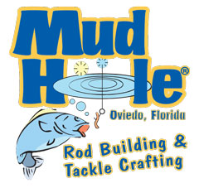
Rod Kit Order Form

Name: ________________________________ Date: _____________
Rods Available
Spinning Rod Kits (reel hangs under rod)
____ EKS56L-Cork 5’6” w/ Cork grips 4-8 lbs $21.00
____ EKS60L 6’ w/ EVA grips 6-10 lbs $15.95
____ EKS60L-Cork 6’ w/ Cork grips 6-10 lbs $19.60
____ EKS60L-2 6’ 2 pc. 2-6 lbs $31.71
____ EKS60M 6’ w/ Cork grips 8-10 lbs $16.45
____ SCK1-S 6’6” 2 pc. 4-8 lbs $22.25
____ EKS66M 6’6” 6-12 lbs $29.08
____ EKS66M-Color 6’6” 6-12 lbs (colored blank) $29.08
____ EKS70UL-2 7’0” 2 PC. 4-8 lbs $37.04
____ EKS70ML 7’0” 4-10 lbs $29.54
____ EKS70ML-Color 7’0” 4-10 lbs (colored blank) $29.54
____ EKS70MH 7’0” 12-25 lbs $31.71
Casting Rod Kits (reel mounted on top of rod)
____SCK1-C 6’6” 2 pc. 4-8 lbs $18.50
____ EKC66M 6’6’ 8-14 lbs $28.03
____ EKC66M-Color 6’6” 6-12 lbs $28.03
____ EKC70ML 7’0” 6-10 lbs $29.16
____ EKC70ML-Color 7’0” 6-10 lbs (colored blank) $29.16
____ EKC70MH 7’0” 12-25 lbs $31.71

Kit total _____________ + Tax (8.25%) ______________ = _______________

